OBJECT ORIENTED PROGRAMMING

Theory Assignment…

**Submitted by:**

**Name:** Md. Shakibul Islam

**ID:** CSE 07808427

**Date:** 5.5.2023

**Ahamed Shafi**

Assistant Professor,

Department of CSE,

Stamford University Bangladesh

***Submitted to:***

**Classes and Objects**

#include <iostream>

using namespace std;

class Student

{

    int scores[5];

public:

    void input()

    {

        for(int i=0; i<5; i++)

        {

            cin >> scores[i];

        }

    }

    int calculateTotalScore()

    {

        int totalScore = 0;

        for(int i=0; i<5; i++)

        {

            totalScore += scores[i];

        }

        return totalScore;

    }

};

int main()

{

    int n;

    cin >> n;

    Student students[n];

    for(int i=0; i<n; i++)

    {

        students[i].input();

    }

    int kristenTotalScore = students[0].calculateTotalScore();

    int count = 0;

    for(int i=1; i<n; i++)

    {

        int totalScore = students[i].calculateTotalScore();

        if(totalScore > kristenTotalScore)

        {

            count++;

        }

    }

    cout << count;

    return 0;

}

***Output***

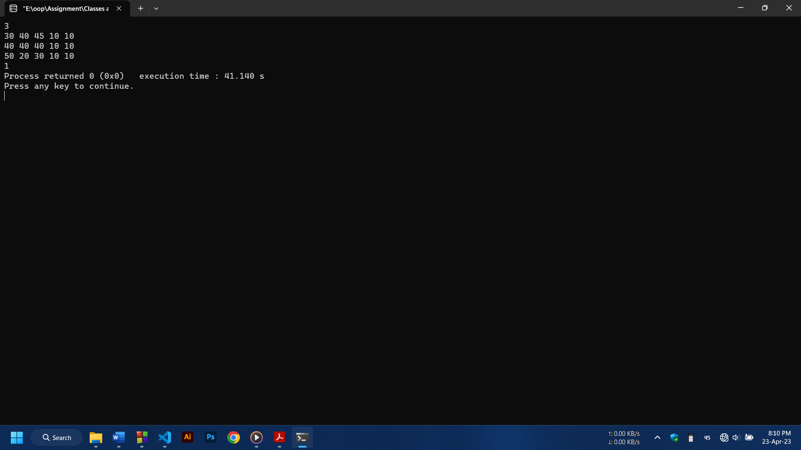

**Class**

#include <iostream>

using namespace std;

class Student

{

    int age;

    string first_name,last_name;

    int standard;

public:

    void set_age(int a)

    {

        age = a;

    }

    int get_age()

    {

        return age;

    }

    void set_first_name(string fn)

    {

        first_name = fn;

    }

    string get_first_name()

    {

        return first_name;

    }

    void set_last_name(string ln)

    {

        last_name = ln;

    }

    string get_last_name()

    {

        return last_name;

    }

    void set_standard(int s)

    {

        standard = s;

    }

    int get_standard()

    {

        return standard;

    }

    string to_string()

    {

        string result;

        result += std::to_string(age) + ",";

        result += first_name + ",";

        result += last_name + ",";

        result += std::to_string(standard);

        return result;

    }

};

int main()

{

    int age, standard;

    string first_name, last_name;

    cin >> age >> first_name >> last_name >> standard;

    Student st;

    st.set_age(age);

    st.set_first_name(first_name);

    st.set_last_name(last_name);

    st.set_standard(standard);

    cout <<endl<< st.get_age() << endl;

    cout << st.get_last_name() << ", " << st.get_first_name() << endl;

    cout << st.get_standard() << endl<<endl;

    cout << st.to_string() << endl;

    return 0;

}

***Output***